Lab 14

Nikita Grabher-Meyer

11/12/2020

# Lab 14

## Minimum Wages and Employment: A case study of the fast-food industry in New Jersey and Pennsylvania

*Data*

setwd("/Users/nikitagrabher-meyer/Desktop/PHD/Econometrics/Labs/Lab 14, Homework")  
  
require(data.table)

## Loading required package: data.table

require(ggplot2)

## Loading required package: ggplot2

require(stargazer)

## Loading required package: stargazer

##   
## Please cite as:

## Hlavac, Marek (2018). stargazer: Well-Formatted Regression and Summary Statistics Tables.

## R package version 5.2.2. https://CRAN.R-project.org/package=stargazer

load("fastfood3.RData")  
load("fastfood4.RData")  
load("fastfood.RData")

*Analysis and Results*

head(dt.fastfood)

## emptot gap demp state chain co_owned atmin meals wage hrsopen pmeal  
## 1: 40.50 0 -16.50 0 1 0 NA 2 NA 16.5 2.58  
## 2: 13.75 0 -2.25 0 2 0 NA 2 NA 13.0 4.26  
## 3: 8.50 0 2.00 0 2 1 NA 2 NA 10.0 4.02  
## 4: 34.00 0 -14.00 0 4 1 0 2 5.0 12.0 3.48  
## 5: 24.00 0 11.50 0 4 1 0 3 5.5 12.0 3.29  
## 6: 20.50 0 NA 0 4 1 0 2 5.0 12.0 2.59  
## fracft time id  
## 1: 0.7407407 0 1  
## 2: 0.4727273 0 2  
## 3: 0.3529412 0 3  
## 4: 0.5882353 0 4  
## 5: 0.2500000 0 5  
## 6: 0.0000000 0 6

*Plots*

*Change in wages*

plot1 <- ggplot( data = dt.fastfood, aes(x = wage))  
plot1 + geom_density() + facet_wrap( ~ state + time) + theme_bw()

## Warning: Removed 37 rows containing non-finite values (stat_density).

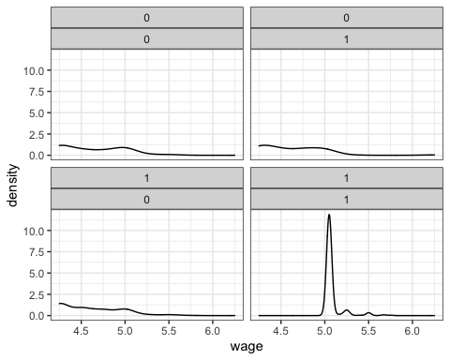

*Change in employment*

qplot( data = dt.fastfood, x = factor(time), y = emptot  
, fill = factor(state)  
, geom = "boxplot") + theme_bw() + xlab("time") + ylab("FTE Employment")

## Warning: Removed 21 rows containing non-finite values (stat_boxplot).

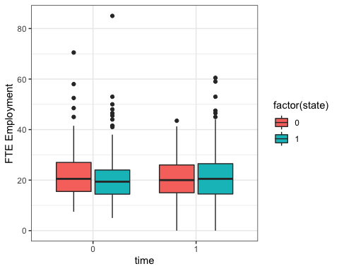

*Means of key variables*

dt.bf.aft <- data.table(dt.fastfood)  
dt.bf.aft <- dt.bf.aft[, list(   
mean_emptot = mean(emptot , na.rm=TRUE)  
, mean_wage = mean(wage , na.rm=TRUE)  
, mean_pmeal = mean(pmeal , na.rm=TRUE)  
, mean_hrsopen = mean(hrsopen , na.rm=TRUE)  
), by=list(state, time)]  
dt.bf.aft

## state time mean_emptot mean_wage mean_pmeal mean_hrsopen  
## 1: 0 0 23.33117 4.630132 3.042368 14.52532  
## 2: 1 0 20.44557 4.610971 3.356471 14.42025  
## 3: 0 1 21.16558 4.617465 3.026620 14.65385  
## 4: 1 1 21.02743 5.080947 3.416809 14.41484

dt.bf.aft.clean <- dt.fastfood[!is.na(wage),]  
dt.bf.aft.clean <- dt.bf.aft.clean[!is.na(pmeal),]  
dt.bf.aft.clean <- dt.bf.aft.clean[!is.na(emptot),]  
dt.bf.aft.clean <- dt.bf.aft.clean[!is.na(hrsopen),]  
dt.bf.aft.clean <- dt.bf.aft.clean[!is.na(emptot),]  
dt.bf.aft.clean <- data.table(dt.fastfood.clean)  
dt.bf.aft.clean <- dt.bf.aft.clean[, list(  
mean_emptot = mean(emptot , na.rm=TRUE)  
, mean_wage = mean(wage , na.rm=TRUE)  
, mean_pmeal = mean(pmeal , na.rm=TRUE)  
, mean_hrsopen = mean(hrsopen , na.rm=TRUE)  
), by=list(state, time)]  
dt.bf.aft.clean

## state time mean_emptot mean_wage mean_pmeal mean_hrsopen  
## 1: 0 0 23.62687 4.651343 3.054062 14.57463  
## 2: 1 0 20.51397 4.609655 3.377033 14.41207  
## 3: 0 1 21.50000 4.618788 3.006406 14.72727  
## 4: 1 1 20.71293 5.082141 3.451808 14.40053

t.test( dt.fastfood.clean[state==0 & time==0, emptot]  
, dt.fastfood.clean[state==1 & time==0, emptot])

##   
## Welch Two Sample t-test  
##   
## data: dt.fastfood.clean[state == 0 & time == 0, emptot] and dt.fastfood.clean[state == 1 & time == 0, emptot]  
## t = 1.9515, df = 84.174, p-value = 0.05432  
## alternative hypothesis: true difference in means is not equal to 0  
## 95 percent confidence interval:  
## -0.05909098 6.28489129  
## sample estimates:  
## mean of x mean of y   
## 23.62687 20.51397

t.test( dt.fastfood.clean[state==0 & time==1, emptot]  
, dt.fastfood.clean[state==1 & time==1, emptot])

##   
## Welch Two Sample t-test  
##   
## data: dt.fastfood.clean[state == 0 & time == 1, emptot] and dt.fastfood.clean[state == 1 & time == 1, emptot]  
## t = 0.66779, df = 103.74, p-value = 0.5058  
## alternative hypothesis: true difference in means is not equal to 0  
## 95 percent confidence interval:  
## -1.550250 3.124388  
## sample estimates:  
## mean of x mean of y   
## 21.50000 20.71293

*Differences in Differences*

(21.02743-20.44557) - (21.16558-23.33117)

## [1] 2.74745

(20.71293-20.51397) - (21.50000-23.62687)

## [1] 2.32583

*Regression*

# Effect on employment  
lm1 <- lm( emptot ~ time + state + time*state, data = dt.fastfood.clean)  
stargazer(lm1, type = "text")

##   
## ===============================================  
## Dependent variable:   
## ---------------------------  
## emptot   
## -----------------------------------------------  
## time -2.127   
## (1.639)   
##   
## state -3.113**   
## (1.286)   
##   
## time:state 2.326   
## (1.818)   
##   
## Constant 23.627***   
## (1.159)   
##   
## -----------------------------------------------  
## Observations 714   
## R2 0.009   
## Adjusted R2 0.005   
## Residual Std. Error 9.486 (df = 710)   
## F Statistic 2.116* (df = 3; 710)   
## ===============================================  
## Note: *p<0.1; **p<0.05; ***p<0.01

coeffs <- coefficients(lm1)  
coeffs

## (Intercept) time state time:state   
## 23.626866 -2.126866 -3.112900 2.325831

dt.bf.aft.clean

## state time mean_emptot mean_wage mean_pmeal mean_hrsopen  
## 1: 0 0 23.62687 4.651343 3.054062 14.57463  
## 2: 1 0 20.51397 4.609655 3.377033 14.41207  
## 3: 0 1 21.50000 4.618788 3.006406 14.72727  
## 4: 1 1 20.71293 5.082141 3.451808 14.40053

21.50000 - 23.62687

## [1] -2.12687

21.50000 - 23.62687

## [1] -2.12687

(20.71293 - 20.51397) - (21.50000 - 23.62687)

## [1] 2.32583

# Add controls for chain and ownership  
lm <- lm( emptot ~ time + state + time*state + factor(chain) + co_owned  
, data = dt.fastfood.clean)  
stargazer(lm, type = "text")

##   
## ===============================================  
## Dependent variable:   
## ---------------------------  
## emptot   
## -----------------------------------------------  
## time -2.127   
## (1.479)   
##   
## state -2.400**   
## (1.163)   
##   
## factor(chain)2 -10.440***   
## (0.895)   
##   
## factor(chain)3 -1.768*   
## (0.903)   
##   
## factor(chain)4 -1.235   
## (1.033)   
##   
## co_owned -1.192   
## (0.754)   
##   
## time:state 2.326   
## (1.641)   
##   
## Constant 26.237***   
## (1.115)   
##   
## -----------------------------------------------  
## Observations 714   
## R2 0.197   
## Adjusted R2 0.189   
## Residual Std. Error 8.562 (df = 706)   
## F Statistic 24.769*** (df = 7; 706)   
## ===============================================  
## Note: *p<0.1; **p<0.05; ***p<0.01

# Change in meal prices  
qplot( data = dt.fastfood, x = factor(time), y = pmeal  
, fill = factor(state)  
, geom = "boxplot") + theme_bw() + xlab("time") + ylab("Meal Price")

## Warning: Removed 53 rows containing non-finite values (stat_boxplot).

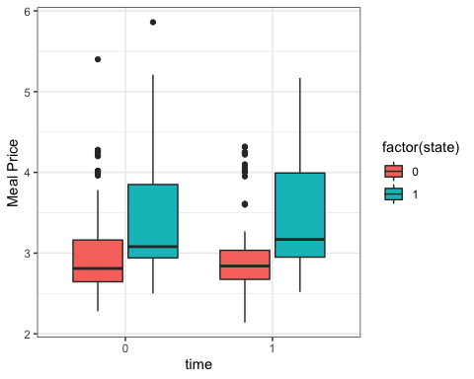

# Effect on meal prices  
lm <- lm( pmeal ~ time + state + time*state  
, data = dt.fastfood.clean)  
stargazer(lm, type = "text")

##   
## ===============================================  
## Dependent variable:   
## ---------------------------  
## pmeal   
## -----------------------------------------------  
## time -0.048   
## (0.113)   
##   
## state 0.323***   
## (0.089)   
##   
## time:state 0.122   
## (0.126)   
##   
## Constant 3.054***   
## (0.080)   
##   
## -----------------------------------------------  
## Observations 672   
## R2 0.055   
## Adjusted R2 0.051   
## Residual Std. Error 0.641 (df = 668)   
## F Statistic 13.058*** (df = 3; 668)   
## ===============================================  
## Note: *p<0.1; **p<0.05; ***p<0.01

# Change in number of hours of operation  
qplot( data = dt.fastfood, x = factor(time), y = hrsopen  
, fill = factor(state)  
, geom = "boxplot") + theme_bw() + xlab("time") + ylab("Hours of Operation")

## Warning: Removed 7 rows containing non-finite values (stat_boxplot).

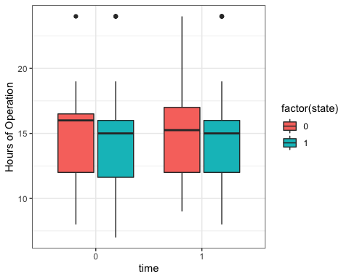

# Effect on hours open  
lm <- lm( hrsopen ~ time + state + time*state  
, data = dt.fastfood.clean)  
stargazer(lm, type = "text")

##   
## ===============================================  
## Dependent variable:   
## ---------------------------  
## hrsopen   
## -----------------------------------------------  
## time 0.153   
## (0.490)   
##   
## state -0.163   
## (0.383)   
##   
## time:state -0.164   
## (0.544)   
##   
## Constant 14.575***   
## (0.345)   
##   
## -----------------------------------------------  
## Observations 707   
## R2 0.001   
## Adjusted R2 -0.003   
## Residual Std. Error 2.825 (df = 703)   
## F Statistic 0.302 (df = 3; 703)   
## ===============================================  
## Note: *p<0.1; **p<0.05; ***p<0.01

# Effect on the fraction of full-time employees  
lm <- lm( fracft ~ time + state + time*state, data = dt.fastfood.clean)  
stargazer(lm, type = "text")

##   
## ===============================================  
## Dependent variable:   
## ---------------------------  
## fracft   
## -----------------------------------------------  
## time -0.033   
## (0.042)   
##   
## state -0.021   
## (0.032)   
##   
## time:state 0.055   
## (0.046)   
##   
## Constant 0.355***   
## (0.029)   
##   
## -----------------------------------------------  
## Observations 708   
## R2 0.003   
## Adjusted R2 -0.002   
## Residual Std. Error 0.239 (df = 704)   
## F Statistic 0.622 (df = 3; 704)   
## ===============================================  
## Note: *p<0.1; **p<0.05; ***p<0.01

# Alternative Specifications  
summary(dt.fastfood.clean$gap)

## Min. 1st Qu. Median Mean 3rd Qu. Max.   
## 0.00000 0.00000 0.06316 0.08553 0.18824 0.18824

lm <- lm( emptot ~ gap * time , data = dt.fastfood.clean)  
stargazer(lm, type = "text")

##   
## ===============================================  
## Dependent variable:   
## ---------------------------  
## emptot   
## -----------------------------------------------  
## gap -20.193***   
## (6.570)   
##   
## time -1.576   
## (1.064)   
##   
## gap:time 15.653*   
## (9.291)   
##   
## Constant 22.825***   
## (0.753)   
##   
## -----------------------------------------------  
## Observations 714   
## R2 0.014   
## Adjusted R2 0.010   
## Residual Std. Error 9.462 (df = 710)   
## F Statistic 3.346** (df = 3; 710)   
## ===============================================  
## Note: *p<0.1; **p<0.05; ***p<0.01